The problem and idea
Thematic investing groups companies by exposure to a structural driver (e.g. AI, clean energy, cybersecurity) rather than by sector. The baskets that express these themes are built by hand: an analyst reads filings, decides which companies count, and assembles a list. That's slow, subjective, and biased toward large caps that already have analyst coverage. It also can't be extended to companies nobody has bothered to classify.

The question is whether we can recover a theme’s membership from return behavior alone, without ever looking at what any index or ETF holds.

The method explored here:
- Defining the ‘theme’.
Take 2-3 existing thematic ETFs per theme (for AI Infrastructure: IGPT, QTUM, SOXX). We use only their price history, never their holdings. The core design choice is that the method uses return histories, not holdings. If this works, it can extend to universes that no index provider has labeled.

I ran this across 11 deliberately diverse themes: AI Infrastructure, Robotics & AI, Cybersecurity, Fintech, Clean Energy, Critical Minerals, Water, Timber & Forestry, Agribusiness, Defense, and US Infrastructure. Each theme is defined by two to three ETFs. The diversity is intentional: some themes are technology-led, some are commodity-linked, some are policy-driven. If the method only worked on one type, we wanted to know. (The use of ETFs was deliberate because the data are public and available, although an extension can be to look at sell-side baskets or custom indices which are used for swaps, but those are not available to public).

- Build a factor space.
Take approximately 2,000 US-listed stocks from the NYSE and Nasdaq, each above $1 billion in market capitalization. These names are large enough to be liquid and well priced, while the universe is broad enough for stable factor estimation. Strip out the known drivers of return: market, size, value, profitability, investment, momentum. What's left is the part of each stock's return that standard risk models can't explain. Run principal component analysis on that residual to extract 15 latent factors - statistical axes along which stocks move together for reasons the standard model doesn't capture. (I use 15 factors so the model has enough capacity for themes to load on separate factors)

- Locate each theme in that space.
Regress each theme ETF's returns on those 15 factors. The resulting loadings are the theme's "fingerprint" - a coordinate in factor space.

- Find matches.
Project every stock into the same space and rank them by proximity to the theme fingerprint. Take the top 30 as the candidate basket.

The 30-stock basket size is a practical choice: it is diversified enough to reduce single-stock risk, but concentrated enough to express a view. I tested other sizes; nothing about the conclusions turns on that number.

- Validation.
At every rebalance date, the model only sees data available at that date. It builds a basket, holds it for the next period, and we measure what actually happened. No lookahead.

A potential extension to the paper (or a pivot):
A question I faced along the way: do the ETFs defining a theme even agree with each other? i.e. are my choices for ETFs to define the themes actually a good choice. (a secondary question relative to the project’s main objective)

Every theme is defined by 2-3 ETFs whose fingerprints we average. That assumes they describe the same thing. In practice, they often do not.

I measure this as
- coherence: how tightly a theme's ETFs cluster in factor space and
- distinctiveness: whether a theme uniquely owns a factor or shares it with other themes.
Both are computable before any basket is built.

Two findings came out of this, and they're among the most useful in the project:
First, themes vary enormously in how well-defined they are. Clean Energy's ETFs disagree substantially with each other. One is weighted toward solar manufacturers, another toward utilities and grid infrastructure. Averaging them produces a fingerprint that describes neither. Cybersecurity's two ETFs, by contrast, agree almost perfectly. This is a real and measurable property of how the industry constructs thematic products, not a quirk of our data.

Second, and perhaps more importantly: several themes don't own a distinct factor at all. AI Infrastructure, Robotics & AI, Water and the broad Technology sector all load most strongly on the same latent axis. They are not statistically separable. Meanwhile Cybersecurity and Critical Minerals do own distinct factors and rank above five of six GICS sector and subsector controls we included as calibration benchmarks.

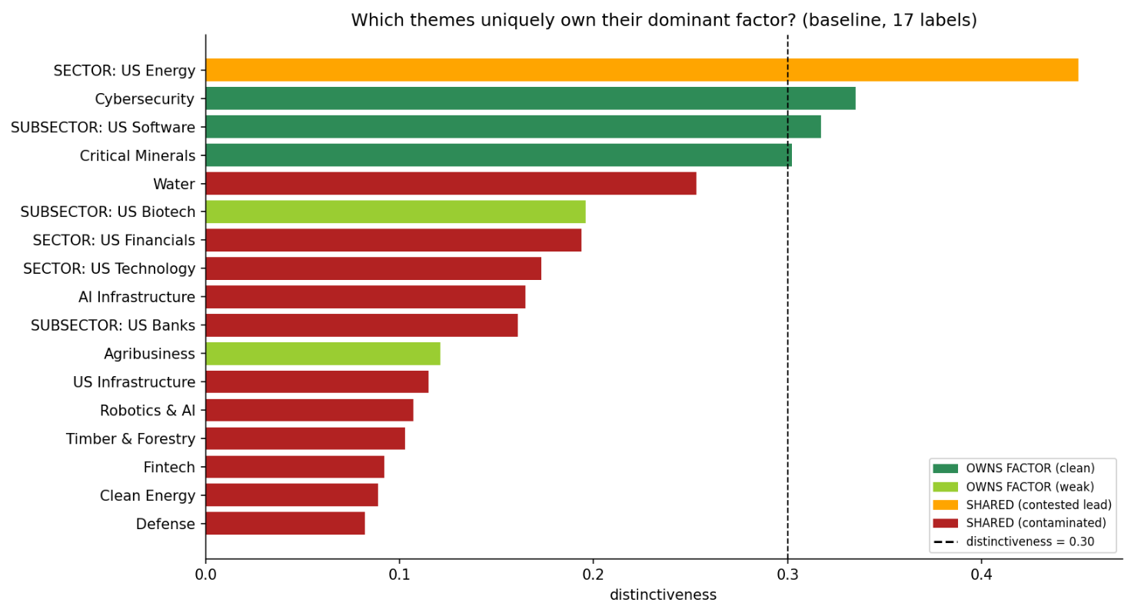

That second finding is the economic argument for thematic classification: in the 2018-2026 sample, AI capital expenditure has fractured traditional sectors internally, so a theme spanning several sectors can be a tighter statistical cluster than the sector it draws from. Coherence turns out to be regime-dependent, not taxonomic.

This opens a natural extension I haven't yet explored so far: using the same diagnostic to compare competing products within a theme. If three ETFs all claim to track Clean Energy but occupy different points in factor space, which one actually captures the theme; and what is an investor really buying when they choose between them? That's a question allocators face directly and currently answer on fees and holdings overlap rather than on statistical exposure.

Two validation measures:

- Basket tracking:
Does the 30-stock basket, as a group, move with the theme ETF? A portfolio-level question.

- Rank IC (information coefficient):
Within those 30, does our ordering carry information? If we say stock A is a better AI match than stock B, does A actually turn out more AI-exposed next period? A value near zero means the ordering is close to random.

I thought this matters practically since a basket you can't rank is a basket you must hold equal-weighted. Without rank information, the basket should be held closer to equal weight because the model cannot identify which names deserve higher conviction. (Most ETFs are market cap weighted or in thematic space can be weighted based on relevance buckets).

Findings and stress tests

The headline: Basket tracking is real but modest. Stock-level ranking is absent (Rank IC). The method appears to find the right neighborhood, which suggests the candidates are thematically related, but it does not rank them reliably within that group.

I tried a few different paths here. Five things could have caused a false negative, and I tested each:

1. Was the stock universe too small? i.e. answering the question what if the theme didn’t have any relevant stock in the universe I am exploring. It initially was the case as I was looking at small caps, but I expanded the universe to all listed US stocks and limited the theme definition to US themes or global themes with clear US players. Sparse data had made the factor estimates unstable initially. This produced the most important methodological lesson of the project: on the small universe we'd found a striking result (a +0.82 correlation between how much a theme's ETFs agreed with each other and how well it ranked). On the proper universe, that same correlation was -0.52. It reversed sign. The original finding was entirely an artifact of noisy estimates from too few stocks.
2. Were the baskets too small to rank? The pipeline applies admission filters so a candidate must explain enough of its own variance through the factor model, must be similar enough to the theme, must match enough of the theme's ETFs. Stacked together, these were cutting the intended 30 stocks down to 3-9. You cannot meaningfully rank 5 stocks. I loosened the filters until every basket filled to exactly 30. Ranking became measurable and it was essentially flat.

3. Is thematic exposure regime-dependent? A real possibility especially as AI theme has been dominating the market recently. For example: Microsoft and Constellation Energy behave like AI names when AI is moving as a theme, and otherwise like a growth stock and a utility the rest of the time. If so, one average relationship across all periods would dilute the signal. I split every period into "theme active" and "theme quiet" and compared ranking in each. Result was 6 of 11 themes better in active periods. I concluded this looked like noise rather than a PCA regime limitation.

4. Are we rebalancing too slowly? I went from quarterly (19 observations) to monthly (55). More data should sharpen a real signal. Instead everything shrank further toward zero and the placebo results got worse.

5. Is our null hypothesis too easy? The initial null test was too weak, so I replaced it. I originally tested against time-shifted themes by taking a real theme and moving it in time. But that preserves the theme's internal structure, so the placebo was still a genuine coherent theme, just from a different period. Because factor structure persists, it retained most of the real signal. I then replaced it with random ETF regroupings: bundle one cybersecurity ETF with two agriculture ETFs, call it a theme, run the identical pipeline. This is potentially the real null: would any arbitrary bundle score similarly? What I found was negative. No theme reaches statistical significance against it.

The pattern that decided it
Across three separate measurement improvements, apparent signal compressed toward zero rather than sharpening:
Water (our best theme) | Rank IC
Small universe, small baskets | +0.34
Proper universe, 30-stock baskets | +0.16
Monthly rebalancing, 55 observations | +0.07

That is diagnostic. Real signal gets clearer as measurement improves; noise gets smaller. The tests show the latter all three times.

For our call, the key question is which framing gives the paper its strongest contribution: thematic stock discovery, thematic risk measurement, product coherence, or the boundary between group level exposure and stock level selection.

1. It answers a question practitioners may be measuring imprecisely. When testing for thematic exposure, for example, a portfolio’s exposure to AI as a thematic risk factor, practitioners typically regress a portfolio on a thematic ETF to get an "AI beta". The results here show most themes don't own a distinct factor. AI Infrastructure, Robotics, Water and the broad Technology sector all load on the same axis. So that AI beta is substantially generic tech exposure. We can give a pre-test for whether a given ETF is admissible as a risk factor at all. No commercial risk vendor currently offers this: MSCI's thematic product scores companies on business fundamentals, and Axioma's flagship model contains no thematic factors.

2. The diagnostic framework appears useful even where the stock selection application is weak. The strongest result is that coherence is regime-dependent, not taxonomic: several cross-sector themes are tighter statistical clusters than the GICS sectors they draw from, because AI capital expenditure has fractured those sectors internally. That's an economic argument for why thematic classification captures something sector classification misses, and it stands independently of anything about basket construction.

Methodological lessons that generalize: The filter trade-off: tightening filters improves tracking but shrinks baskets below the size where ranking can be measured at all, so an analyst optimizing for the headline metric silently destroys their ability to test the central claim.

3. The negative result can itself be the contribution. "Can you recover tradeable thematic baskets from returns alone?" is a question people assume has a positive answer. We tested it carefully, ruled out five alternative explanations for failure, and can say with evidence: group exposure appears recoverable; stock selection does not. That's a real boundary, and knowing where a method stops working is worth publishing.

Possible next direction:
Perhaps the natural home is thematic risk measurement rather than stock discovery. Measuring a portfolio's exposure to a theme needs group-level signal, which works. Building a tradeable basket needs selection skill, which the evidence says isn't there.

The ETF comparison question above (gray background) can be a second, closely related direction. Essentially using the same diagnostic machinery, pointed at product selection rather than stock selection. The framework, the diagnostics, and the negative result all point the same way.

